Alignment to CEDS Elements

Before uploading a data file, a map for it must be created in Align. See the Align Module 1 tutorial “Creating a Map,” available at https://ceds.ed.gov/learnCedsAlignment.aspx for information on how to create a map.

The data are in Align… now what?

The next step is to align each map element to one or more CEDS elements. To do this, each map element is reviewed for context. Contextual clues include the element’s location in the data source, the element name, and the element definition. This information helps determine the appropriate CEDS element to which the map element will be aligned.

CEDS elements are divided into ten domains:
- Early Learning
- K12
- Postsecondary
- Adult Education
- Career and Technical Education
- Workforce
- Assessments
- Learning Standards
- Learning Resources
- Authentication and Authorization

A map element’s location in the data source indicates which domain in CEDS is most relevant. Determining the appropriate CEDS element involves navigating through multiple levels of categories until reaching the appropriate set of elements (see figure 1).

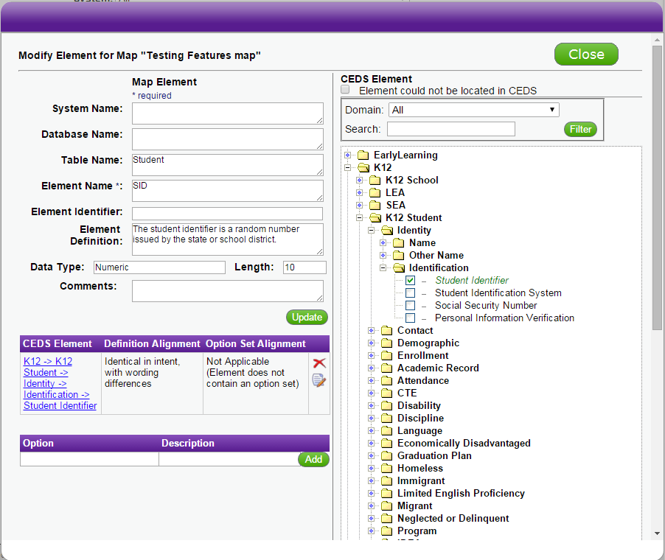

Figure 1. CEDS Element Tree View

CEDS element names are hyperlinked to a full description of the element (see figure 2). Reviewing the CEDS element definitions is essential to the alignment process.

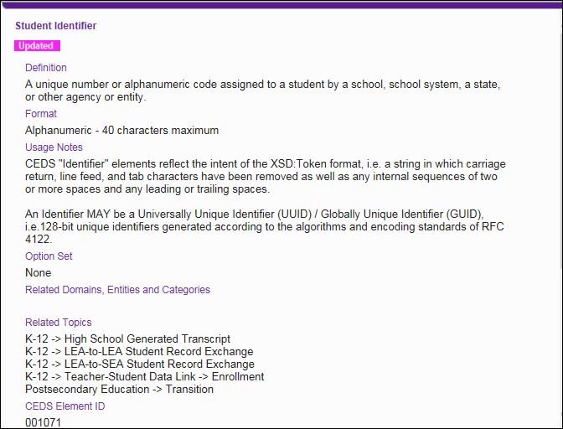

Figure 2. CEDS Element Details

Keep in mind that there will be situations where multiple CEDS elements are necessary to align to the map element.

Sometimes searching through the element tree view does not result in locating an appropriate CEDS element. The search function can then be used to ensure that the appropriate CEDS element is selected or that no matching CEDS element exists (see figure 3).

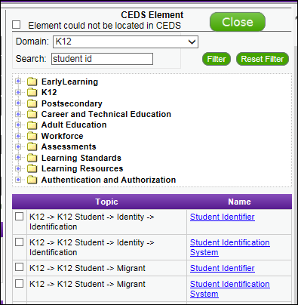

Figure 3. Align Search

If a search within the DES from Align is not successful, a more comprehensive search can (and should) be done from the Elements page (see figure 4).

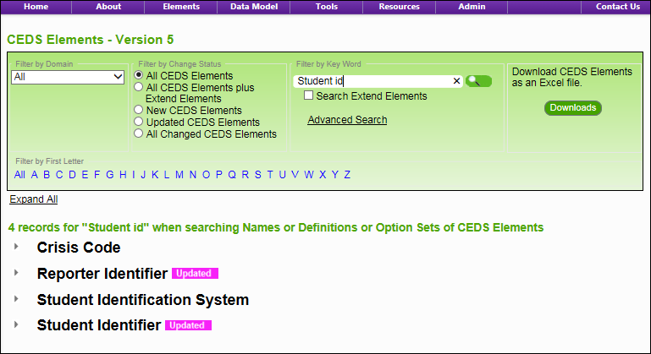

Figure 4. Search from Elements
If, after exhausting these options, no CEDS element is considered a match, the map element should be marked “Element Could Not Be Located in CEDS” (see figure 5). Note: Elements marked in this way are reviewed each year for relevance and potential inclusion in later versions of CEDS.

Figure 5. CEDS Could Not be Located

When a CEDS element is considered a match, a review of the map element’s definition and the CEDS element’s definition must be undertaken to indicate the alignment between the two definitions. Similarly, a review of the map element’s option set and definitions and the CEDS element’s option set and definitions must be undertaken to indicate the alignment between the two option sets. When the CEDS element check box is selected, a popup box appears for use in determining the definition alignment and option set alignment (see figure 6).

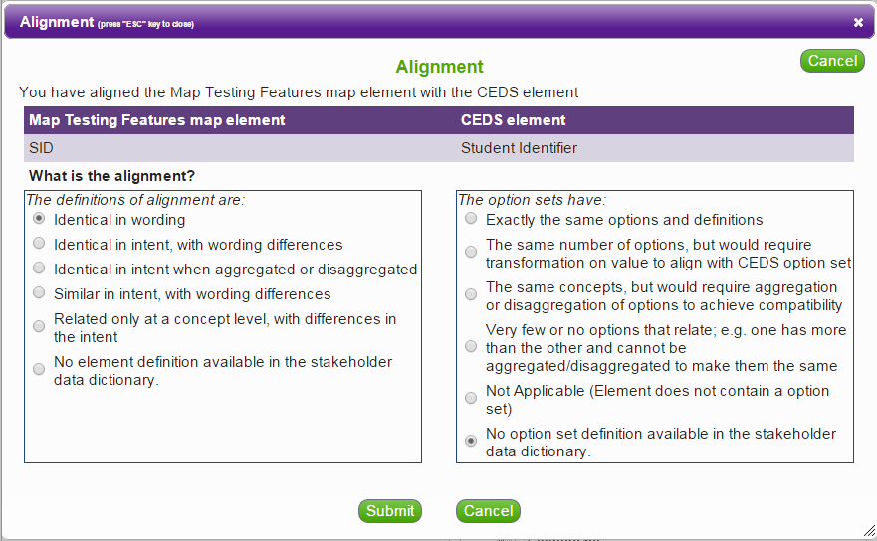

Figure 6. Alignment Questions

The definition alignment question has six possible options. The user must determine which category the definitions of alignment fall into:

- Identical in wording. The user should select this option if the definition is exactly the same as that of the CEDS element.
- Identical in intent, with wording differences. The user should select this option if the definitions have exactly the same intent, but are not worded exactly the same.
- Identical in intent when aggregated or disaggregated. The user should select this option if the data source element is divided among multiple elements and the CEDS element is a single element, or vice versa. A common example of this is race, where a data source collects race as a single element and CEDS has each race listed as a separate element.
- Similar in intent, with wording differences. The user should select this option if the two elements have a similar intent, but are not close enough for identical intent; there are slight variations.
- Related only at a concept level, with differences in the intent. The user should select this option if the two elements can be related conceptually, but the actual usage of the data source element would not be the same as that of the CEDS element. For example, the element “Age” may be aligned to the CEDS element “Birthdate.” However, the elements are only related on a concept level; they have differences in intention.
- No element definition available in the stakeholder data dictionary. The user should select this option when the data source does not provide a definition for a given element.

For the alignment to be truly accurate, users cannot align to a definition that does not exist. So, while it may be easy to infer a definition from certain element names (e.g., “First Name”), users should use the “No element definition available in the stakeholder data dictionary” when no definition exists.

The code set alignment question also provides six options, many of which are similar to those for the definition alignment question. The user must determine which category the option sets fall into:

- Exactly the same codes and definitions. The user should select this option if the codes are exactly the same as those of the CEDS element.
- The same number of codes, but would require transformation on value to align with CEDS code set. The user should select this option if both elements have the same number of codes for the same purpose, but the codes themselves are different. For example, the data source element “Gender” provides the codes “M” for Male and “F” for Female. The CEDS element, “Sex,” has “Male” for Male and “Female” for Female. To align the element to the CEDS element, it would require transformation from “M” to “Male” and “F” to “Female.”
- The same concepts, but would require aggregation or disaggregation of codes to achieve compatibility. Similar to the definition alignment, the user should select this option when one element has more codes than the other, but the codes can be combined or separated to make them the same. To continue the race example, “Race” is collected in the data source as a single element with multiple codes (e.g., African American, Asian, American Indian, Native Hawaiian, and White). CEDS, on the other hand, has separate elements for race with “Yes,” “No,” and “Not Selected” as possible codes. The data source element’s codes would need to be disaggregated in order to match the CEDS element.
- Very few or no codes that relate, e.g., one has more than the other and cannot be aggregated/disaggregated to make them the same. The user should select this option when the data source element varies enough that its codes are entirely different from those of the aligned CEDS element. Any sort of combination or separation of the codes would not result in alignment with the codes in the CEDS element.
- Not applicable (element does not contain a code set). The user should select this option when an element does not have an option set. Examples of this are “First Name” or “Student Identification Number.” These are elements for which an option set would not exist.
- No code set definition available in the stakeholder data dictionary. When a code exists for an element, but no definition is provided for the code, then the user should select this option.

The element alignment process is repeated for each data element in the map. While the alignment described here is a manual process in the Align tool, alignment can also be included in the Microsoft Excel file and uploaded to the tool. Instructions for including alignment in the Microsoft Excel file can be found in the upload template. Aligning elements via the tool has proven to be a more efficient method than alignment via Microsoft Excel. The Microsoft Excel template requires the user to enter codes specific to the CEDS element as well as codes for the two alignment questions. To upload alignment via Microsoft Excel, the user must use the CEDS website to find elements, definitions, and code sets; use a Microsoft Excel spreadsheet to locate the appropriate CEDS element’s ID; and then manually enter that element ID into the file to be uploaded. The process takes much longer than the Align tool process and is generally recommended when a data source being uploaded has multiple instances of the exact same element, where the information can be copied and pasted to multiple rows.

